Q2)

i)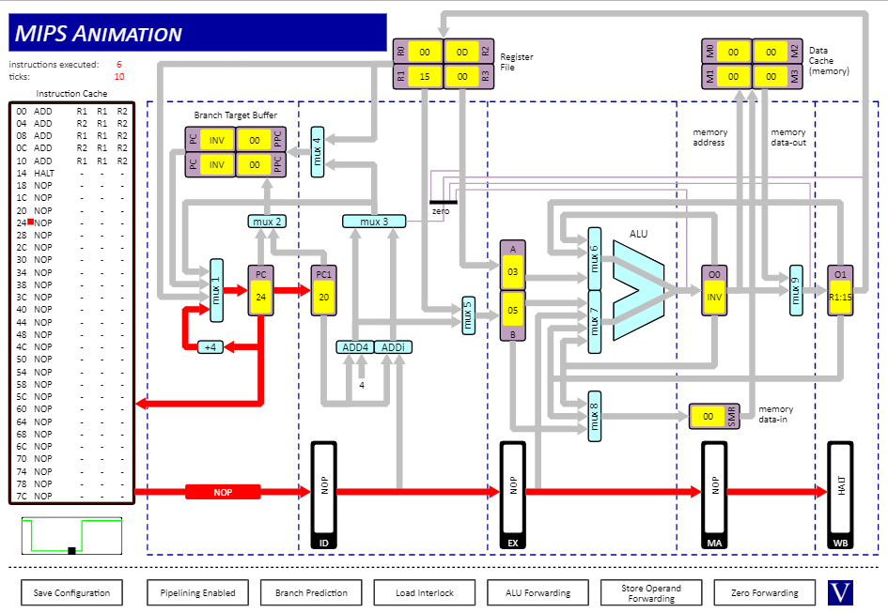fastest time, least amount of clock cycles. Processor is able to see what registers are being used and if they need to wait before executing the next instruction

ii)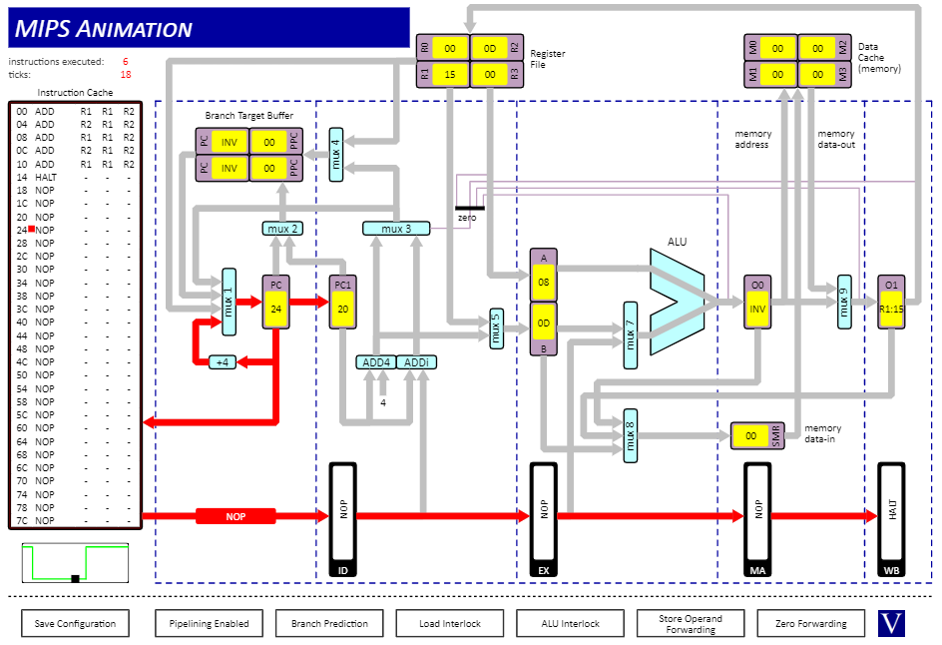more clock cycles than the previous example, the processor needed to check the data dependencies as the processor needs to evaluate the result of the previous instruction before those registers are used again

iii)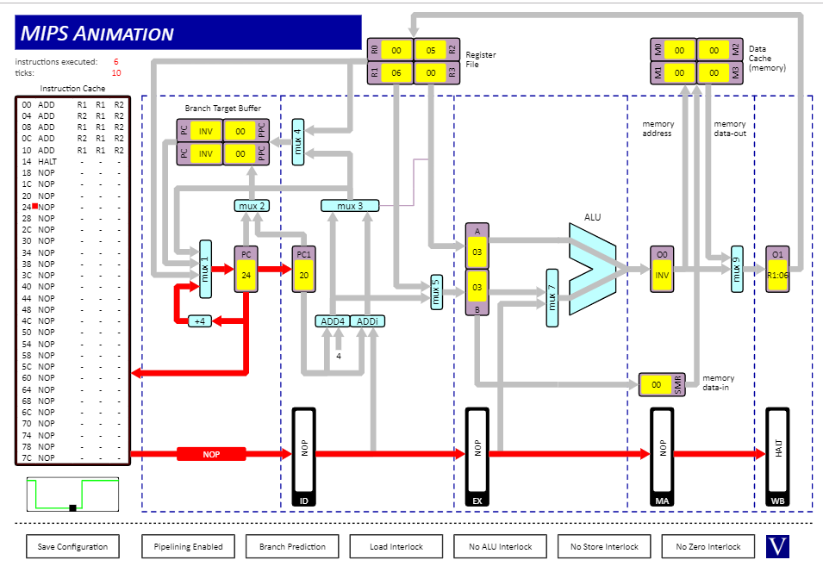the result came out wrong because the processor doesn’t check if the registers have been properly evaluated before executing the next instruction